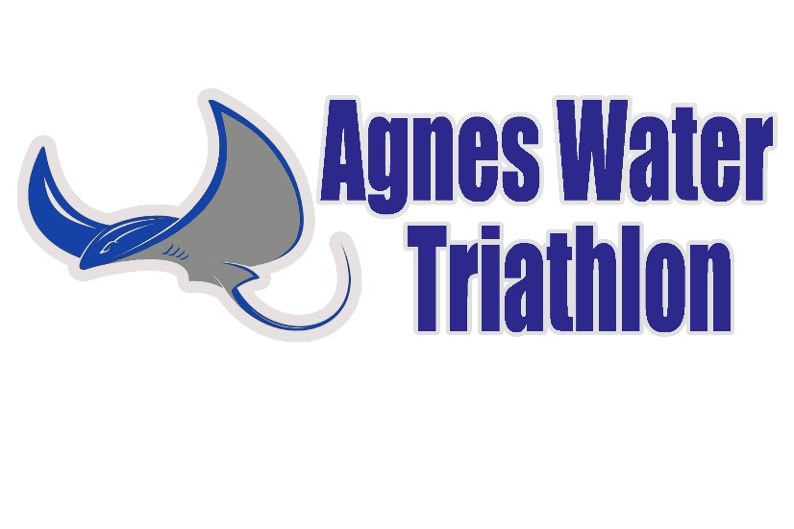
Bendigo Bank Agnes Water Triathlon
Sunday 3rd October, 2021.
Athlete Information Guide
Introduction
Thank you for choosing to participate in the annual Agnes Water Triathlon. We hope enjoy the event and have enough time to stay for a few days to explore our little piece of paradise.
Please print this guide and read it carefully. It contains everything you need to know for the race. Due to current social distancing requirements, there will be no briefing on race day morning. Although we will have a short gather round briefing before the start to explain the transition flow and update you with any last minute information.
The triathlon has been sanctioned by Triathlon Australia and a TA technical official will be in attendance to help ensure fair play and adherence to race rules.
Please support all of the sponsors listed on our website, as they help make our event possible. And a special thanks to Bendigo Bank for being our major sponsor for five years running. They have been awesome in their support. And also to Agnes Water Pharmacy as major sponsor of the Junior Aquathlon which is such an important event for our future champions.
Venue
Tom Jeffery Park, Agnes Water, at the beach end of Agnes Street, off Springs Road.

Schedule of events
Saturday 2nd October
1.00pm till 2.00pm – Check in. This is the preferred check in time for those who are able.
Sunday 3rd October
6.00am till 7.00am – Check in, bike racking and transition set up.
7.05am – Final race update and Q & A’s
7.10am – move down to beach for swim warm up
7.30am – Enticer event starts. Based on entry numbers, probably a mass start.
7.45am – Sprint distance event starts. There will be wave starts. Wave start times will be advised on race day morning.
10.00am approx. – Presentations to be held as soon as possible after the last athlete has finished and results are checked for accuracy.
Parking
The preferred parking area is Endeavour Plaza shopping centre car park, approx. 200m from transition. A small number of parking spots may be available on Jeffery Court.
If your accommodation is close by, please consider riding your bike to the race venue.
Please DO NOT park anywhere along Agnes Street as this is part of the bike course. Parking along here creates a hazard for cyclists. And we may have to delay the race start whilst owners are tracked down and cars are moved.
Baggage
Your bags can be left under one of the Bendigo marquees (where you check in). This is an unsecured area so please don’t bring any valuables with you to the event, other than enough for food & refreshments. Car keys may be left at the check in desk.

Venue facilities
Tom Jeffery Park is a beautiful shaded park with toilet and shower facilities. There will be ample room to spread out and practice social distancing. The local Dragon Boat club will be doing a sausage sizzle after the race, and you can buy a coffee or refreshments from nearby cafes.
We will have personnel from Qld Ambulance Service and Capricorn First Aid Providers in attendance, to treat any medical issues.
Bike mechanic
Rushys Bicycle Servicing will be set up in the park on Saturday afternoon (during the aquathlon) from 1.00pm and also, from 6.00am on race morning. Rushy will be happy to assist with any bike problems you may have, and also to do any last minute services or pre race checks. (the latter needs to be pre booked T 0402 244 071). Rushy has been servicing bikes for 25 years and does a great job.

Race morning – Bike and transition set up
As you enter transition on race morning, an official from Triathlon Australia will do a brief helmet and bike check. Please ensure you have your helmet on and fastened as you enter transition.
Please vacate the transition area as soon as you finish setting up. Bike racks will not be numbered. Solo competitors can rack where ever there is space available. Team cyclists do not rack bikes.
The Course
Please refer to the course maps on our website https://www.agneswatertriathlon.com/copy-of-triathlon in conjunction with the following notes.
The actual course distance is:
Sprint distance: the swim will be as close as possible to 750M, the bike is about 18.5 klms and the run is 4.8 klms.
Enticer distance is half of the sprint distance.
Swim Leg
Please BYO swim cap. A swim cap will be compulsory for all athletes.
The swim will start close to water’s edge.
Due to the high tide on race day, there will be very little wading.
There is almost always a surf break to negotiate before getting into deeper water. If you are not a strong swimmer, take your time getting out through the break and keep your breathing under control.
SLSQ lifeguards will provide water safety. If you need assistance for whatever reason, shout out or raise your arm to attract attention.
As per Triathlon Australia rules, wetsuits may be worn if the water temperature is below 22 degrees Celsius. But it is highly unlikely that wetsuits will be allowed, as water temp in early October is usually 23 - 24C.
Please respect your fellow competitors during the swim. No argy bargy!
If the water conditions are too dangerous to allow for a safe swim, the event will become a duathlon (run/bike/run). Further details below. A final decision will be made at 6.30am, and communicated to competitors.
Bike Leg
Roads will be closed to normal traffic for the duration of the bike leg.
Roads are mostly flat, except for a small hill at around the 1 klm mark.
It is an out and back course along Springs Road, with the turnaround at the Deepwater National Park turnoff. Sprint athletes do two laps, Enticer athletes do 1 lap. The turnaround point for the second lap is just outside of the transition area.
The bike ride is on an ordinary rural road with a coarse bitumen surface. It is NOT a fast bike course. And due to the nature of the road, light weight, race tyres are not recommended due to the increased risk of punctures.
BIKE RULES:
Your torso must be covered for the duration of the bike and run legs of the event.
After entering transition from the swim you must put your helmet on and secure it BEFORE you remove your bike from the rack. And upon finishing the bike leg, you must leave your helmet on until you have racked your bike in transition.
Always ride to the far left hand side of the road.
If passing another rider, call out so they know you are approaching and always pass on the right hand side (never on the left).
This is a non drafting race. Always stay at least 10 metres behind a rider in front. And if you decide to pass, do so as quickly as possible. Ours is a small regional event and we will not have people on course to police the drafting rule. It is up to each individual to ride safely and fairly and entirely under their own steam.
The Run
The run is mostly flat, with a couple of undulations near the turnaround point. There are a couple of narrow sections on the run course.
Sprint athletes do 2 laps of the run course. Enticer athletes, 1 lap.
It is likely to be hot on the run. Make sure you are well hydrated before the race starts. And drink whilst on the bike. There will be one water station on the run, at about the half way point to the turnaround. So you will pass it twice in order to complete a lap. Water will be in plastic cups – self serve only. The finish line is in Tom Jeffery Park close to transition.
Teams Information
Team swimmers, upon exiting the water, you run up to the right hand (northern) side of transition where the team cyclists will be waiting in a holding area (alongside the wooden fence). Note that team cyclists do not rack your bikes with the solo competitors. Swimmer tags cyclist who then walks bike to mount/dismount line and heads out for the bike ride. At the completion of the bike, the cyclist tags the team runner, who then heads out onto the run leg.
Duathlon Contingency Plan
If water conditions are too rough to allow for a safe swim (SLSQ will make this call, in conjunction with organisers), the race will change to a duathlon.
The call on this will be made at 6.30am, to allow competitors enough time to rearrange their equipment. And the course will be advised in the gather round.
Adjusted race distances will be:
Enticer: 700m run (lap of Jeffery Court) / same bike ride (apx. 9.25klm / same run 2.4 klm
Sprint: 2.4 klm run (one lap of run course) / same bike ride 18.5 klm / same run 4.8 klm
Timing and results
We will have electronic timing, with swim, bike & run splits, courtesy of Event Wizards. Results will be accessible via a link on our facebook page a few hours after the event, and later, via the website.
At check in, you will be issued a timing chip, which is programmed to your race number. Place securely, but not tight, around your left ankle. You should be able to fit a finger between the band and your ankle. Do not alter or modify it in any way. Please notify timing official if you lose the chip, or withdraw from the event. Please note, no timing band/chip = no race time and placing.
Corona Virus
The Agnes Water Triathlon will adhere to advice and protocols issued by Triathlon Australia. Due to changing rules and requirements, we will issue advice to all competitors in the week leading up to the event, along with any other race day information.
For now, please note that you should not attend the event if you are feeling unwell, or are displaying any of the CV symptoms. The same goes for any of your friends, family or supporters.
And we ask that all competitors and spectators adhere to the spread minimization protocols which are in place in our daily lives.
In the unlikely event that we have to cancel the event due to CV, all competitors will be offered either a full refund (less software processing fee) or a transfer of your entry to 2022. [please note: no refunds for any other reason].
Spectators
We welcome all spectators, friends and families of competitors. Feel free to move around and cheer on the athletes, each time they pass through the transition area. Just a couple of no go areas for spectators, being:
- No one is allowed in the transition area, except for athletes and race officials; and
- Please stay well clear of the bridge whilst competitors are exiting the swim and running up to transition.
We also ask that all spectators adhere to social distancing rules, throughout and after the event.
Keep up to date
Regular event updates will be posted on the Agnes Water Triathlon Facebook page. This will be the primary means of communication to competitors. But any important race information will also be communicated by email, to all competitors.

